Create a simple cloud software application for Hospital information system for SIMATS Hospital using any Cloud Service Provider to demonstrate SaaS with fields of patient name, age, address, phone, email, Attender name, attender phone, doctor name, diseases, etc.

Step1: Implementing a Software Application for Hospital Information system.

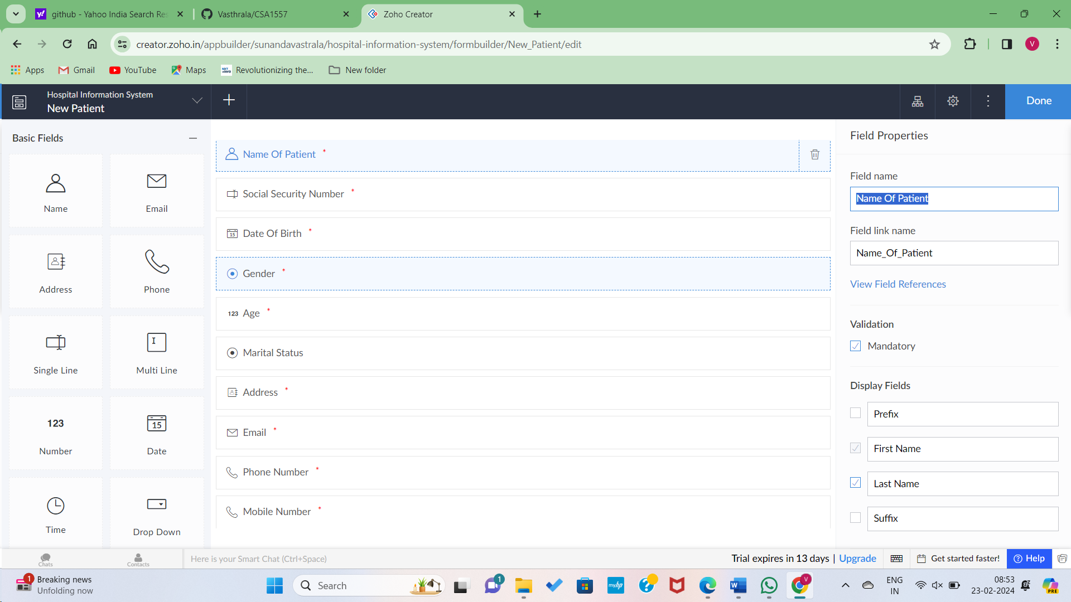

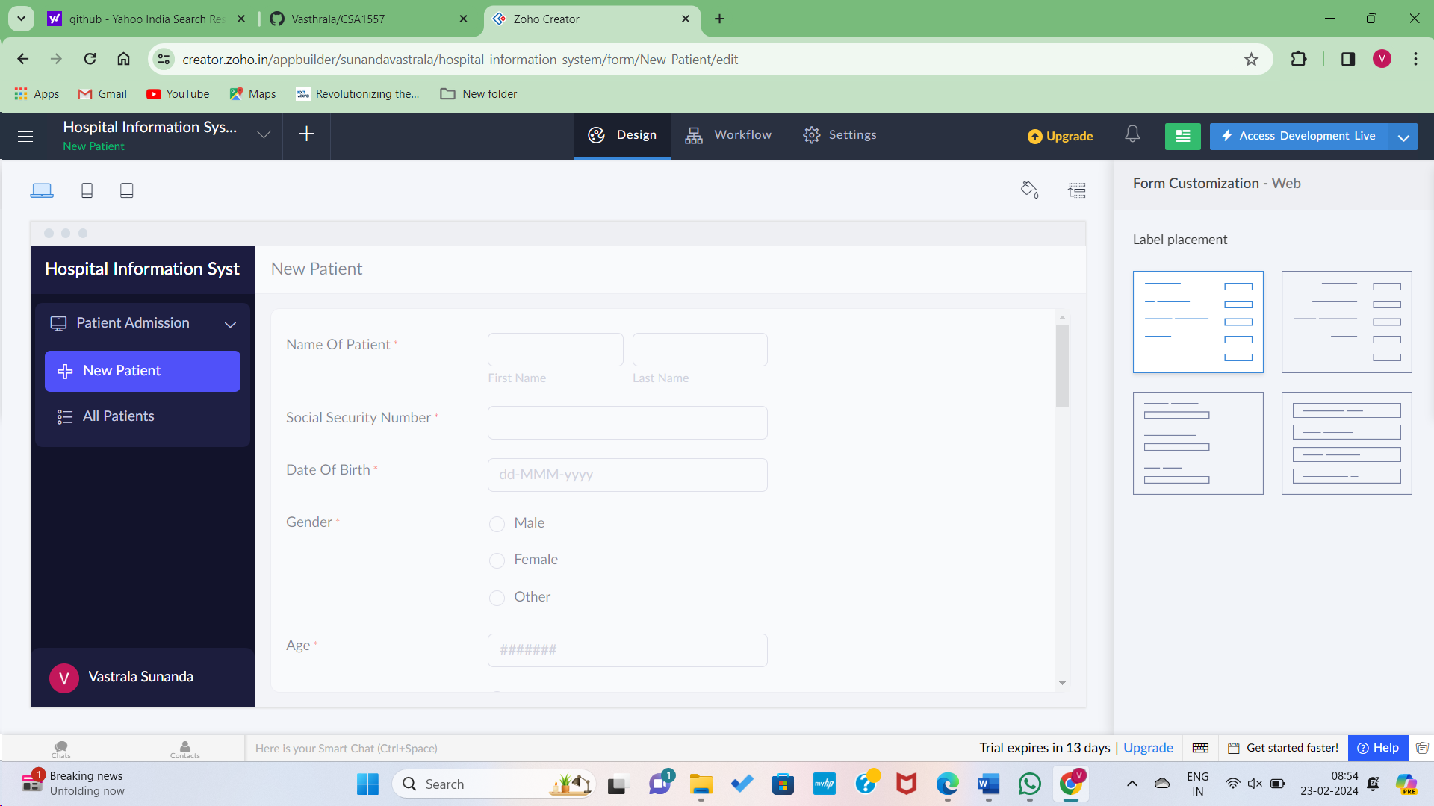

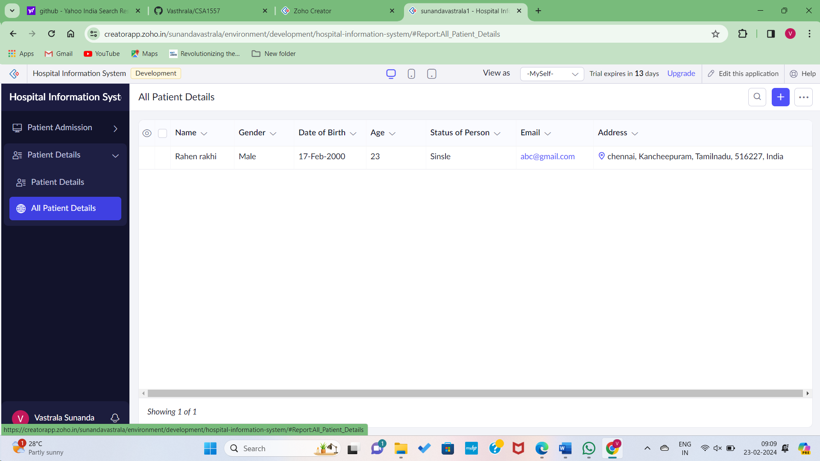

Step4: Implementing a feature to add patient medical tests.

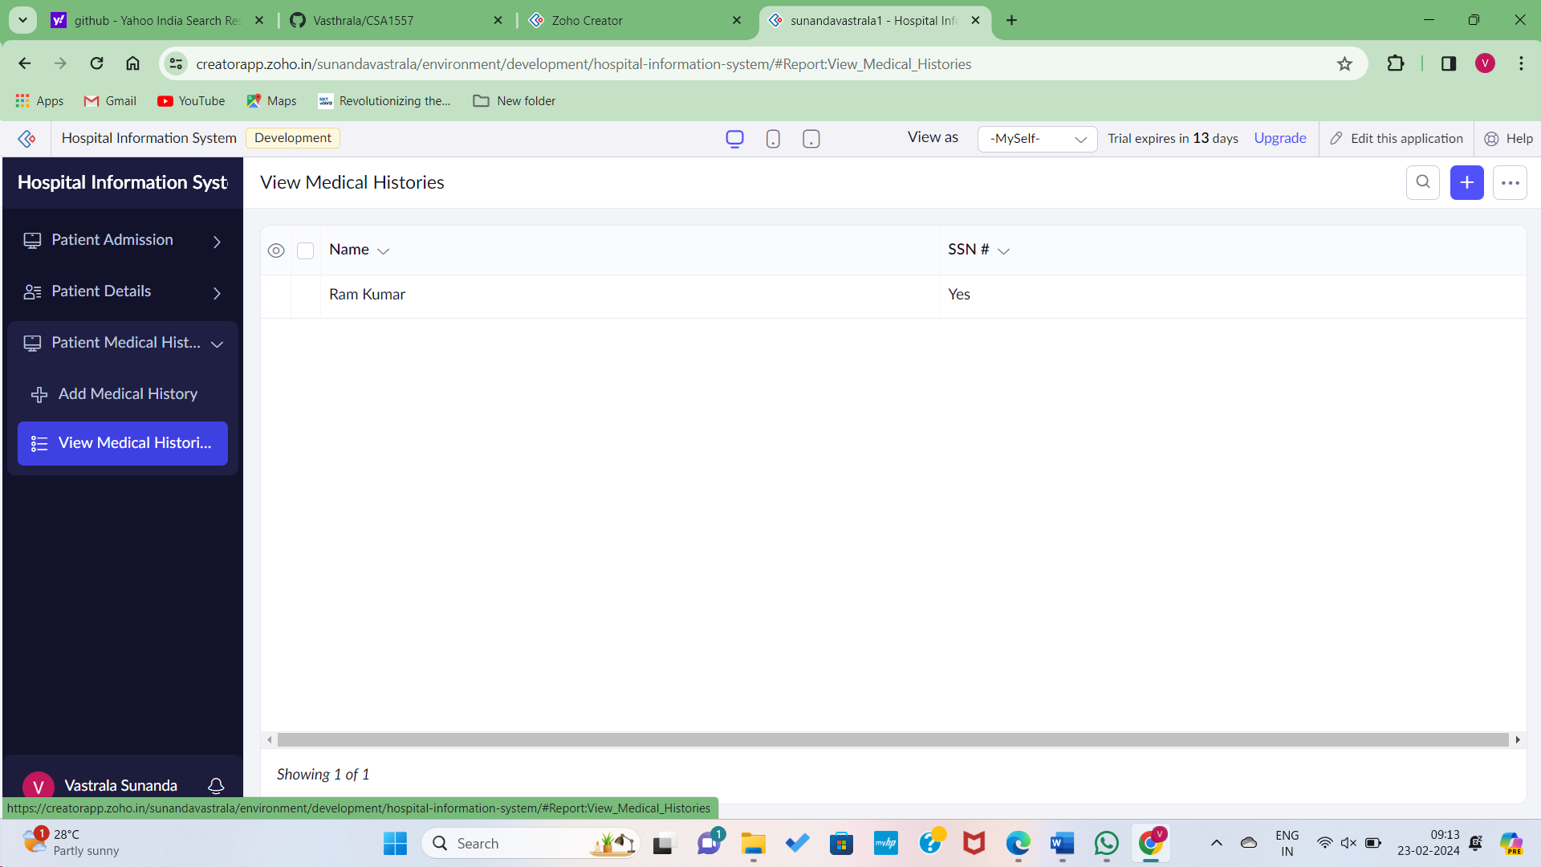

Step5: Implementing a feature for the application lab and results.

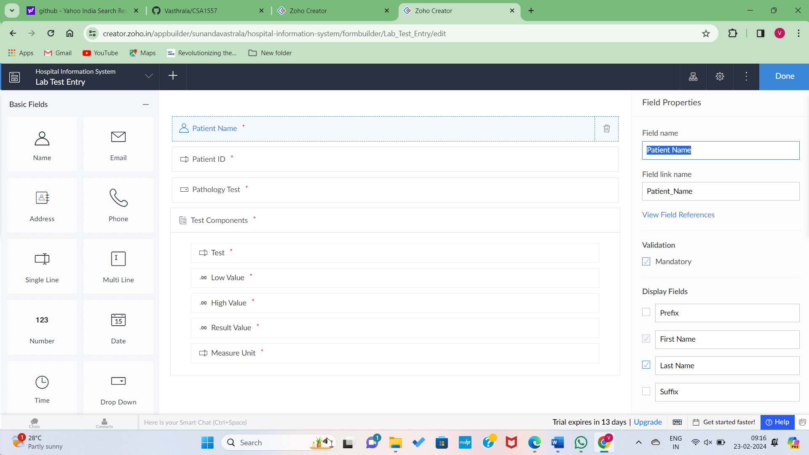

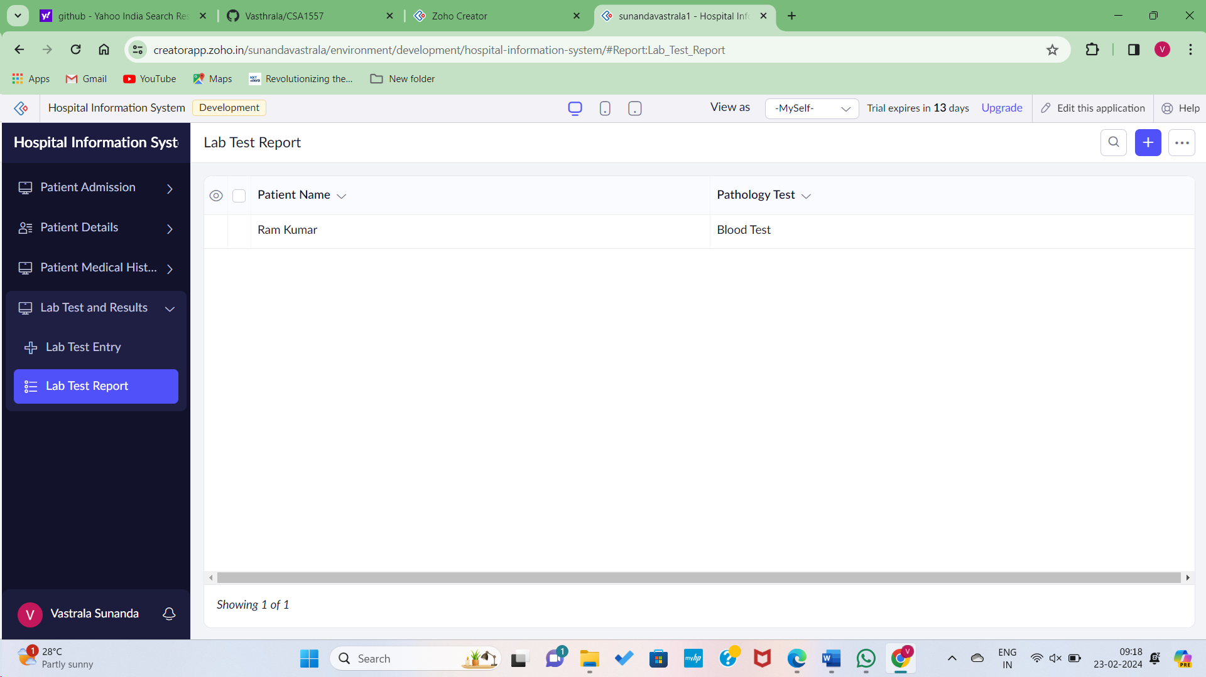

Hence the software application created on Hospital information system